International Rally Drivers Club
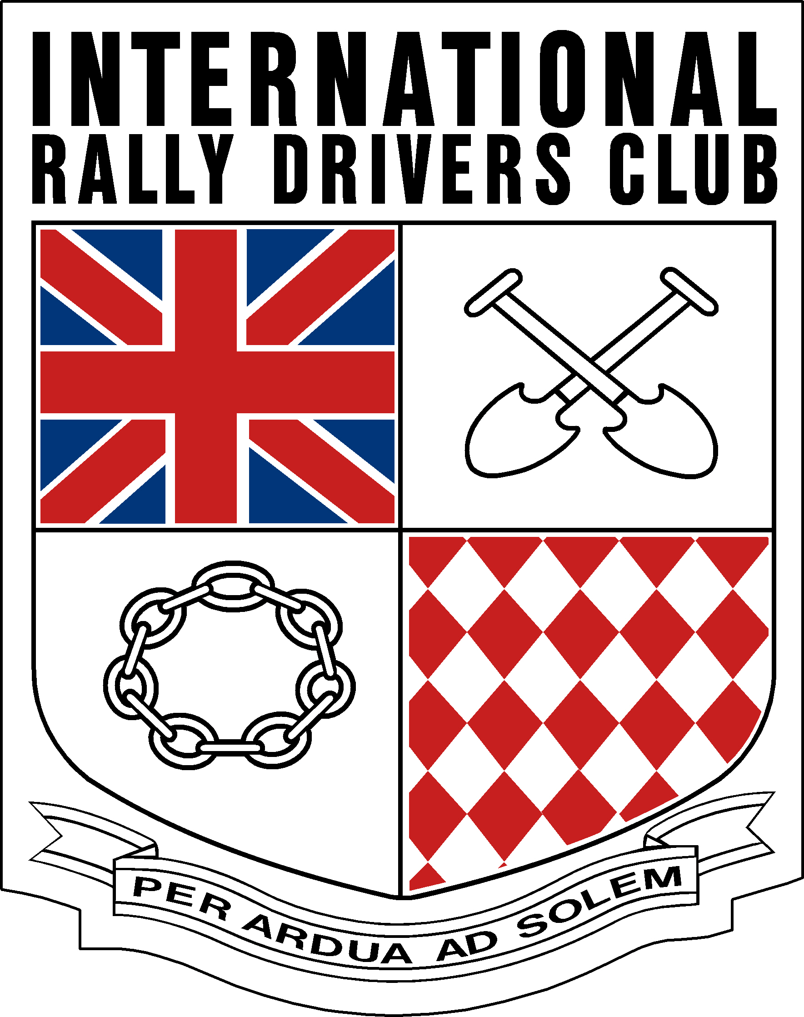

Membership Application form

THIS APPLICATION IS A [PLEASE DELETE WHICH IS NOT APPLICABLE] NEW / RENEWAL / LAPSED

Membership is open to all competitors who have (a) started at least one International Rally, or (b) have started one National rally under the jurisdiction of a National organisation other than the National organisation which issued their competition licence, or (c) A genuine love for the sport of Rallying (forms will be screened for suitability)

Please complete in BLOCK CAPITALS
Surname..................................Dr/Mr/Mrs/Miss.....................Initials.............. First name.................................
Address.......................................................................................................................................................................................................................................................................................................................................................................................................................................................................................................................
…................................................................................Postcode …..................... Country....................................
Telephone, Office………………………………………………..... Home…………………………………........................................... Mobile……………………………………………………………………
Occupation ……………………………………………………………..E-mail………………………………………………………………………….
……………………………………………………………………………………………………………………………………………………………………..
Please give details of the most recent National or International rally that you have started:
Rally…...................................................................................................................Year …..................................
How did you hear of the IRDC………………………………………………………………………………………………………………………
Are you prepared to help with the administration of the Club? Yes/No………………………………………………………

Ways to pay

- Direct Debit: Set up a direct debit electronically with electronic banking or your App. Contact your bank or building society for more details. This will come out annually on your anniversary date of joining. Payment ref:………………………………………………………………..
- Electronic transfer: Please send the correct amount to Sort Code (20-12-21) Acct No (00516929) Payment ref: ………………………………………………….
- Cheque: to South Cottage, address below made payable to the International Rally Drivers Club.

Membership is £ 25 UK, Europe and Worldwide € 30 Euros or sterling equivalent.

In all cases please return the form to: IRDC Membership, South Cottage, Loxwood Chase. Billingshurst. West Sussex. RH14 0QW. UK Or email to; shaunmartin8@gmail.com And sign

I confirm payment as detailed above and apply to join the International Rally Drivers Club in accordance with the Constitution and Rules and authorise my details to be published in printed and/or electronic form.

Signed _____________________________________________Date _______________________________

